**1232. Check If It Is a Straight Line :-**

Easy Accepted: 166.9K Submissions: 410.5K Acceptance Rate: 40.7%

You are given an array coordinates, coordinates[i] = [x, y], where [x, y] represents the coordinate of a point. Check if these points make a straight line in the XY plane.

**Example 1:**

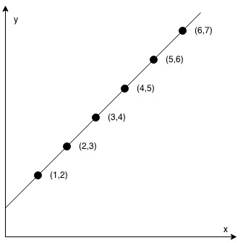

**Input:** coordinates = [[1,2],[2,3],[3,4],[4,5],[5,6],[6,7]]

**Output:** true

**Example 2:**

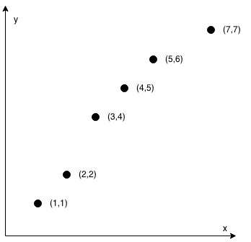

**Input:** coordinates = [[1,1],[2,2],[3,4],[4,5],[5,6],[7,7]]

**Output:** false

**Constraints:**

* 2 <= coordinates.length <= 1000
* coordinates[i].length == 2
* -10^4 <= coordinates[i][0], coordinates[i][1] <= 10^4
* coordinates contains no duplicate point.

**Code :-**

class Solution {

public:

    bool checkStraightLine(vector<vector<int>>& cord) {

        int n = cord.size();

        if(n==2)    return true;

        int count=0;

        for(int i=1; i<n; i++){

            if(cord[i][0]==cord[i-1][0]){

                ++count;

            }

        }

        if(count!=0)

            ++count;

        if(count == n)  return true;

        else if(count!=n && count!=0)   return false;

        else if(count==0){

            float prev = (float)(cord[1][1]-cord[0][1]) / (cord[1][0]-cord[0][0]);

            for(int i=2; i<n; i++){

                float now = (float)(cord[i][1]-cord[i-1][1]) / (cord[i][0]-cord[i-1][0]);

                if(now!=prev)

                    return false;

            }

            return true;

        }

        return false;

    }

};

**T.C :- O(coordinates.length)**

**S.C :- O(1)**